python3 classify_image.py --model models/driverdistraction.tflite --input images/img_11.jpg

python3 classify_image.py --model models/driverdistraction.tflite --labels models/distraction_labels.txt --input images/img_11.jpg

GCP

Training time: 5 hours Edge at max 10 node hours

Results (precision, recall, etc.) posted in GCP.

CoreML

Training Time: hours at 25 max iterations

25 iterations

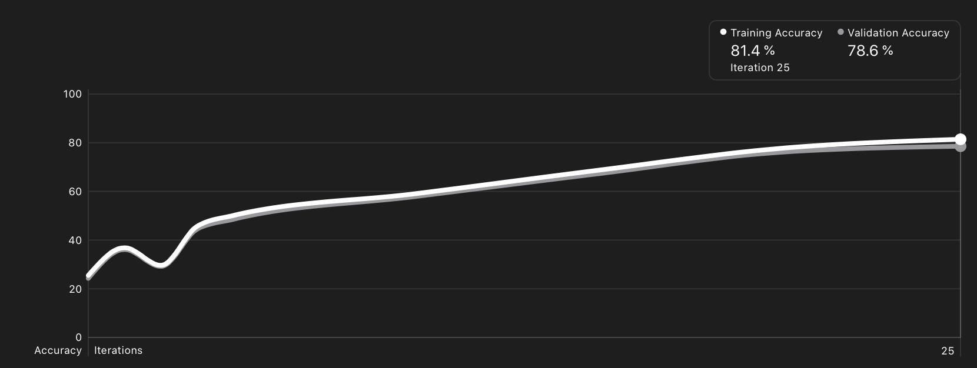

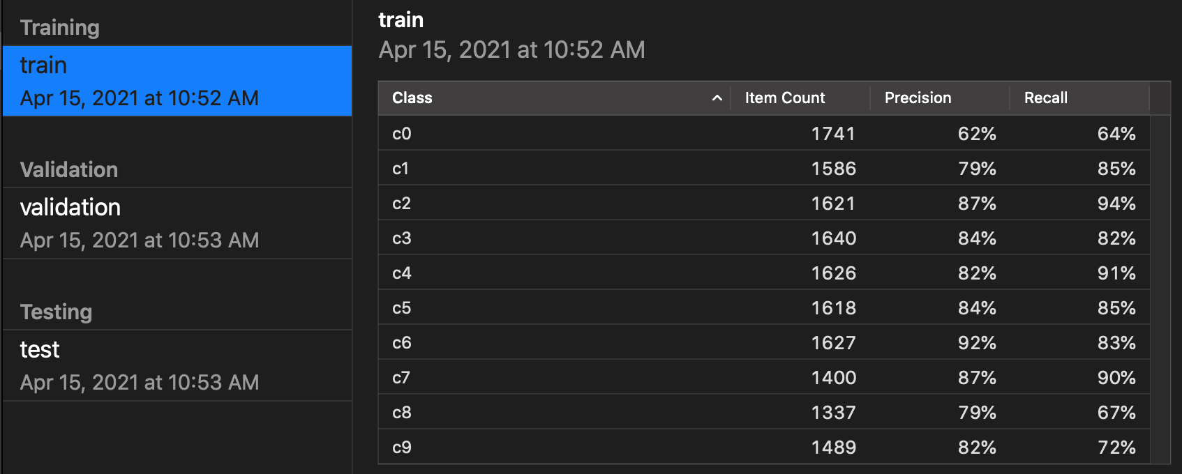

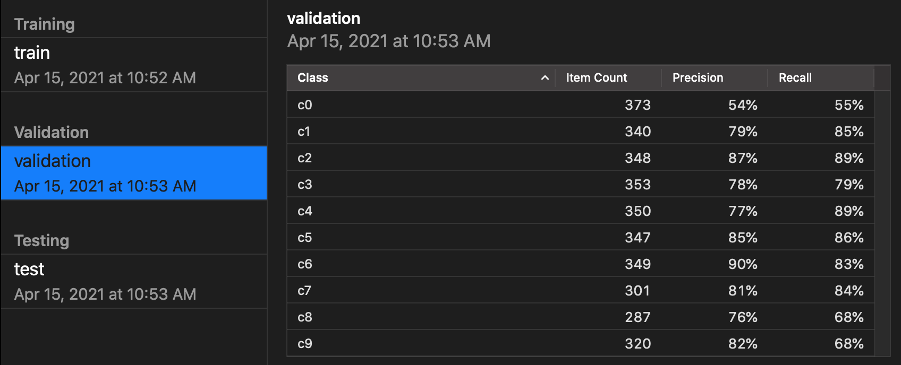

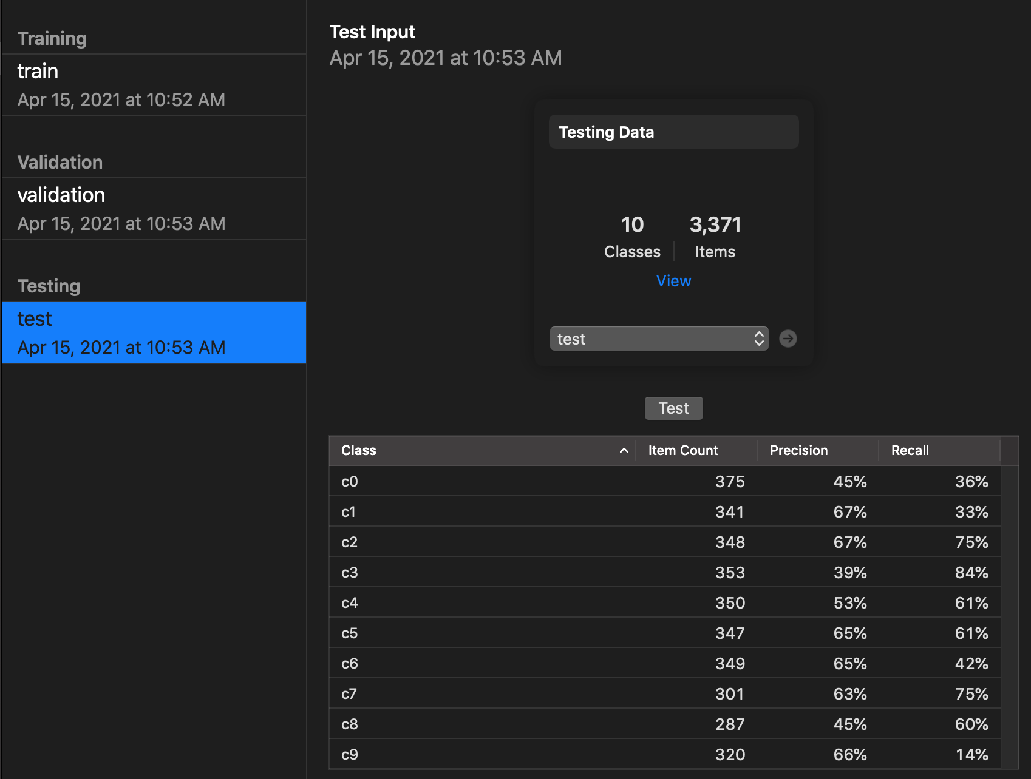

200 iterations:

